1. Boolean:

(“n”+”hi”)==”nhi” true

7<6 false

* 1. true

1. Flow chart:

Flowchart is a map that shows steps and logic for the algorithm

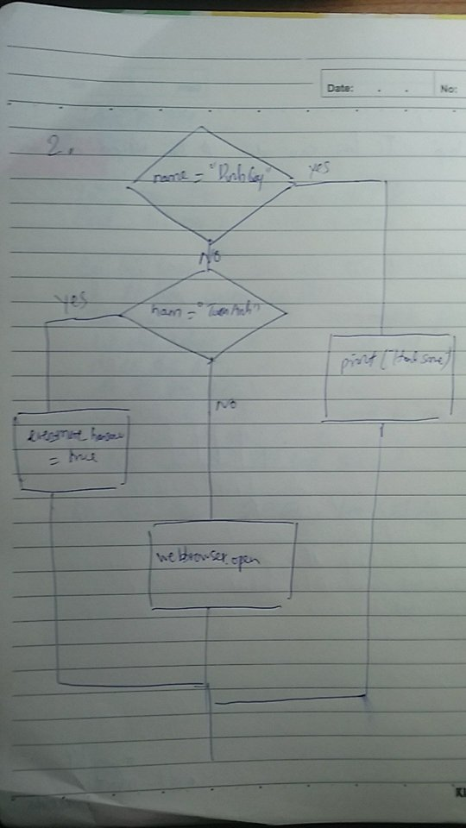

1. Nested conditionals:

Nested conditionals is when a condition contains multiple conditions.

